.

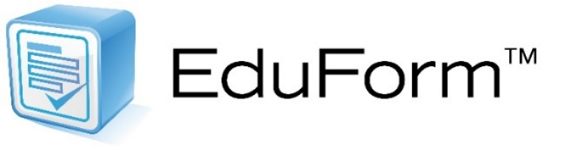

EduForm is a sophisticated product for the development & use of integrated online forms linked to any Student Information System (SIS)
& other required district/BOCES databases:
- Creates exclusive forms to meet any need & requirements
- Converts any existing paper form into an online, web-based form
- Maintains course, section, homeroom, & specials relationships
- Displays any student demographics, program, & other data
- Auto-populates from other data systems to make informed decisions
- Secures login with LDAP, SAML, & Google authenticator
- Offers customizable approval paths & notification
- Uses web-based SSL security & fully encrypted
- Exports data on-demand to any system
- Links directly to SafeSchoolsNYTM, DataMateTM, StaffTracTM, Curriculum DeveloperTM, & Academic Intervention Management System (AIMSTM)
- Keeps all information housed & available on-demand for 26 years
Rev. 7.9.18
Ask Scott B. Crowder for a demo!
scrowder@edvistas.com

